Innovative digital skills and teaching methods for effective health education in Lebanon and Syria

598243-EPP-1-2018-1-SE-EPPKA2-CBHE-JP

Quality report

Steering Committee Meeting (27-30 November 2019, Sweden)
Methodology
Collection of data was based on an on-line questionnaire. The 15 questions and related requests for further details, comments and suggestions, aimed at verifying the satisfaction of participants concerning mainly organization, communication and achievements.
The questionnaire has been administered to the 6 partner organisations participating in the meeting. All of them have completed the questionnaire.
Represented organisations were: Linnaeus University (LNU), Sweden; Damascus University (DU), Syria; Arab International University (AIU), Syria; Lebanese University (LU), Lebanon; Modern University for Business and science (MUBS), Lebanon; Mediterranean Universities Union (UNIMED), Italy.

Meeting organization
In terms of accommodation, no particular problems were highlighted by participants and the satisfaction rate is in average good. Information and support for arranging practical issues were provided even if it has been pointed out that a detailed agenda of the meeting should have been sent ahead.

Degree of involvement and satisfaction
The degree of involvement and satisfaction is good. While some of the partners considered it positively, just few of them weren’t satisfied with the sharing level of the decision-making process. The workshop held during the partners’ meeting focused on the recent trends in Digitalization of Higher Education has been assessed by all the participants interesting and helpful to strengthen their knowledge and skills.

Aspects of the meeting that was considered particularly good
- The meeting allowed participants to share views and ideas about the project.
- Joint work has been mentioned as a strong point.
- The workshop on the digitalization of Higher Education has been assessed as particularly interesting, in terms of contents and interaction with the trainer.

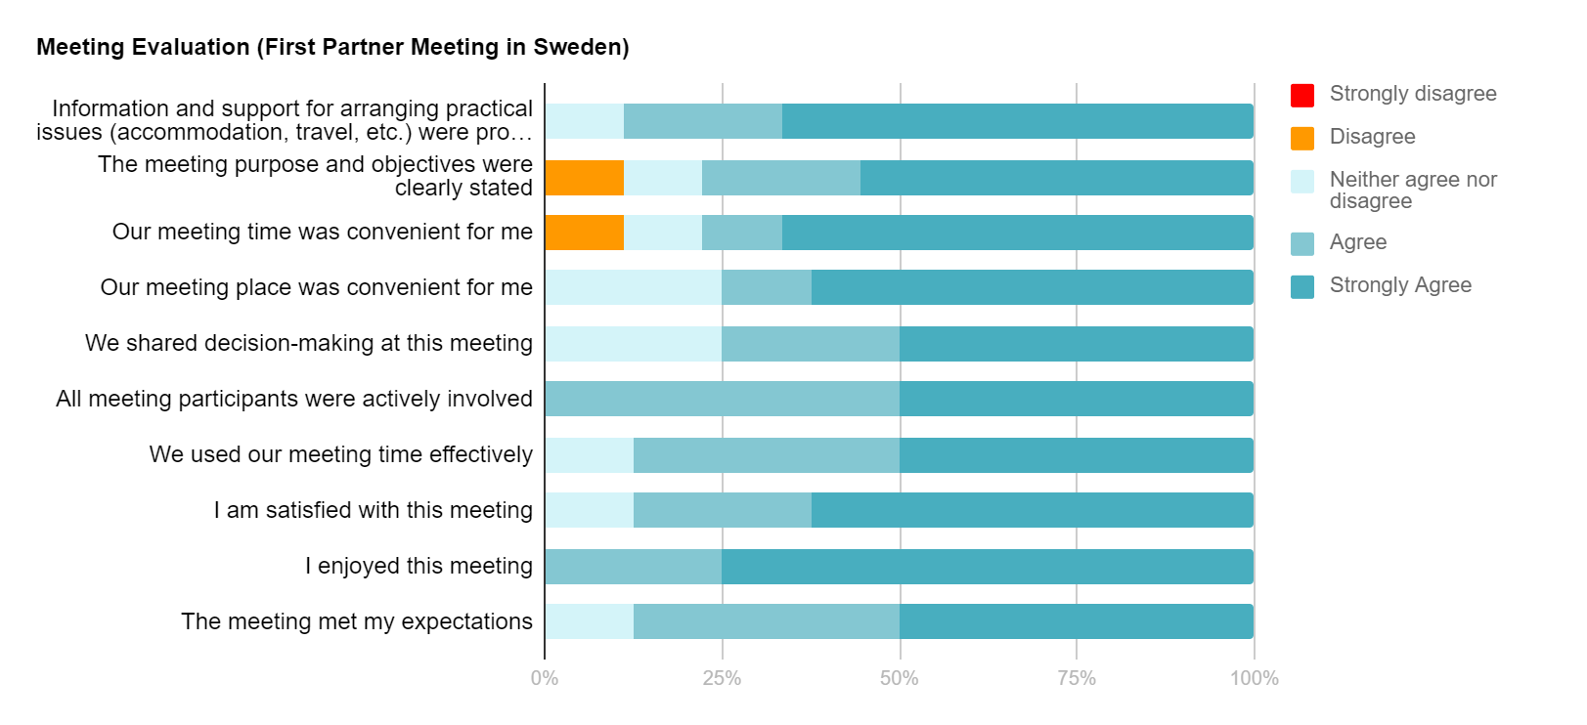

Conclusions
The questionnaire outcomes show that the organisation of the meeting has been assessed in average good. Nevertheless, some partners pointed out the confirmation for the dates, place and agenda has been delivered only a few days before the meeting, causing some problems in terms of travel organisation and visa application. Because of logistical problems some partners failed to attend the meeting. The participants underlined that the partners were very active and contributed to the discussion on all points of the agenda. The communication, both with the coordinator and with the other partners, has been considered quite satisfactory by the participants.
In conclusion, the first partner meeting has achieved the objectives set, even if not all the project partners attended the meeting. The discussions and the collaboration between the partners have been assessed satisfactory and the meeting enhanced the partnership dimension by strengthening the relations between the partners of the project.

