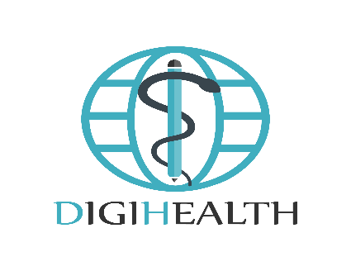 

**Erasmus+ Capacity Building in Higher Education 598243-EPP-1-2018-1- SE-EPPKA2-CBHE-JP**

**Innovative Digital Skills &Teaching Methods 4 Effective Health Education in Lebanon & Syria**

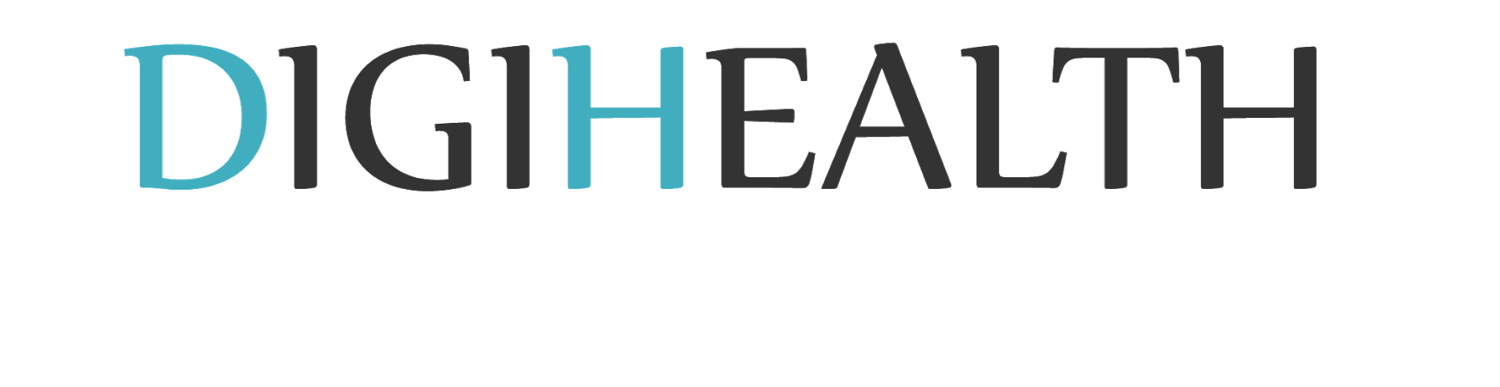

[***mailto:digihealth.education@gmail.com***](mailto:digihealth.education@gmail.com)

**This document has been prepared by the AIU team.**

